**Website Testing Document**

**Wnw19njx - 500547040**

**Task 1. Cross-browser compatibility:**

While developing this website, there were several issues that arose with Google Chrome(v 80.0.3987.163). The most common being crbug.com/332189 which causes a css issue on page load. The resolution suggested for this issue is to place an empty script tag at the end of the page. Since applying this fix, this hasn’t reoccurred.

Microsoft Edge and Mozilla Firefox had difficulties displaying the Parallax effect used on the “serve-comm” class. Firefox corrected this by resorting to ‘background-attatchment: scroll’ instead of fixed. Edge is unable to resolve this and displays the background image at 200% its size. This has been solved by removing the effect to reduce cross-compatibility issues.

Initially, the website didn’t work well on mobile and tablet. Div content was overflowing, images weren’t in the right positions, etc. Using media queries, the css was changed to better suit the layouts given by smaller devices.

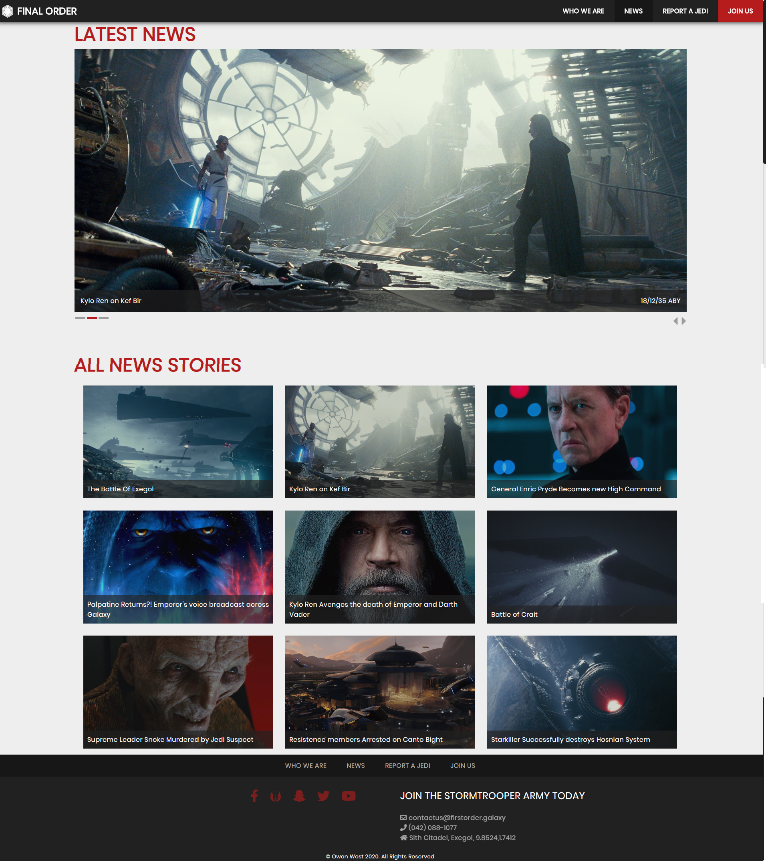

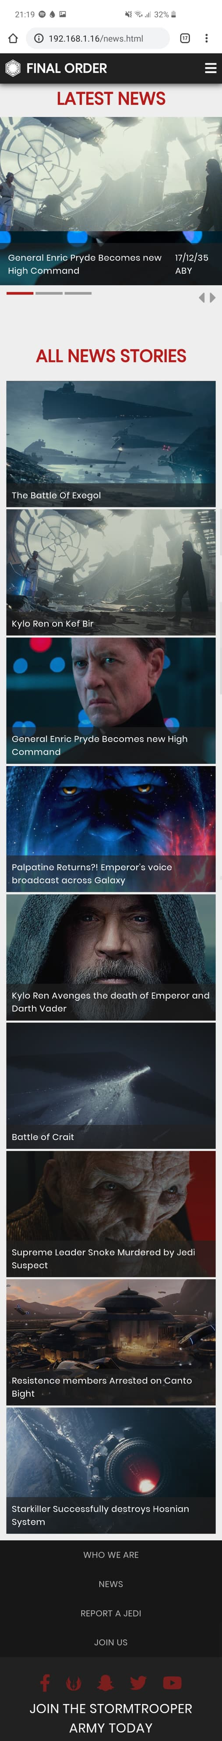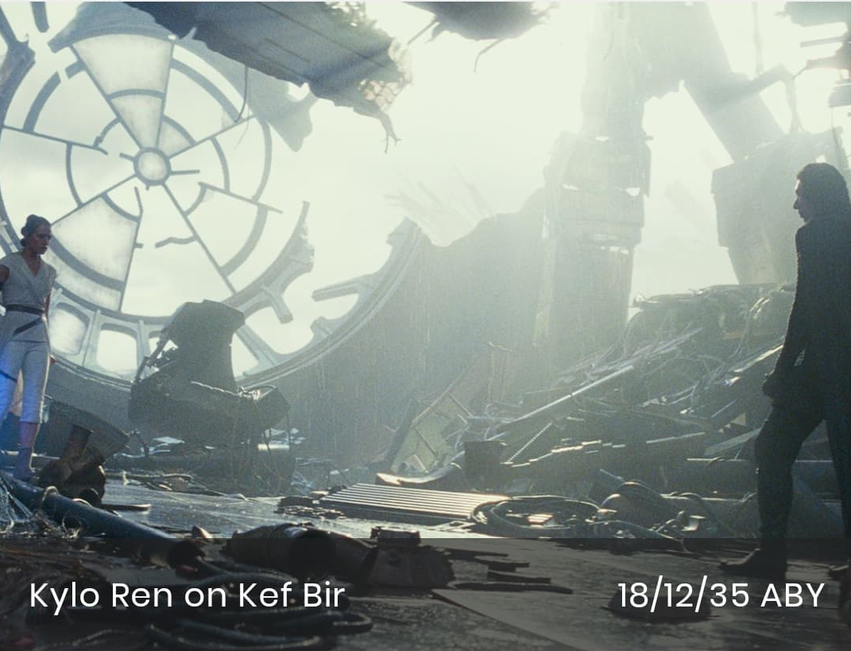

This page displays a vast majority of the dynamic JS content. It stretches from 3x3 on desktop, to 2x4 with one full width on tablet. And on mobile it displays one ‘.news-thumbnail’ at a time. There are no cross-browser problems after testing on smartphone (android and iOS), tablet (through android emulator and Chrome’s developer tools) and desktop (Chrome, Mozilla Firefox and Microsoft Edge).

There is only one problem across devices, landscape mode on mobile doesn’t work very well. Because of the vh method used, it basis the height on device height. This causes content to be more wide and thin than expected. However because this isn’t a common method of browsing a website, it isn’t as important to focus on

**Task 2. HTML/CSS Validation**

Use the W3C HTML and CSS validators to check your website once it is live on the StudentWeb server. List the pages and write something for each along the lines of:

*Some errors were reported (and describe what these were). These were fixed. The screenshot below shows the validation page.*

*OR*

*Some errors were reported (and describe them) and I was unable to fix them.*

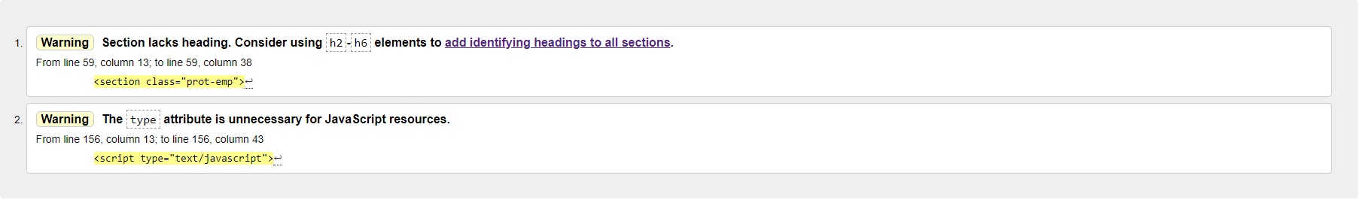

On Index.html, these two bugs showed when using w3’s validator. The 2nd bug was simple to fix by removing the type attribute. The first was not as simple, the section attribute has different expectations of what h1-h6 are. By placing the header into a div, w3 did not show this problem again.

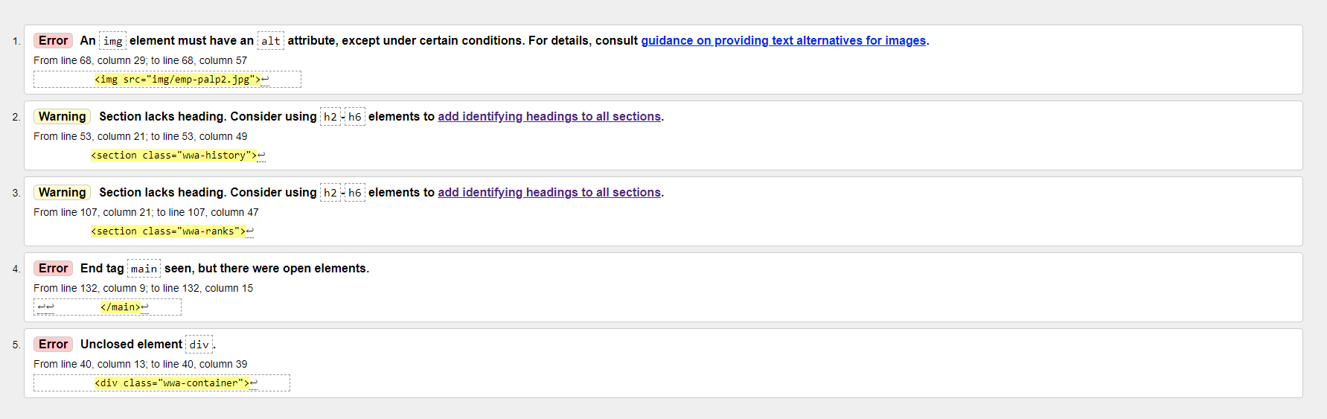

For ‘whoweare.html’, these errors showed. After adding an alt to the image, moving the headings to within the sections and closing the “.wwa-container” div, no more errors occurred. Moving the position of headings caused some css layout problems, which were fixed by changing the ‘flex-direction’ attribute.

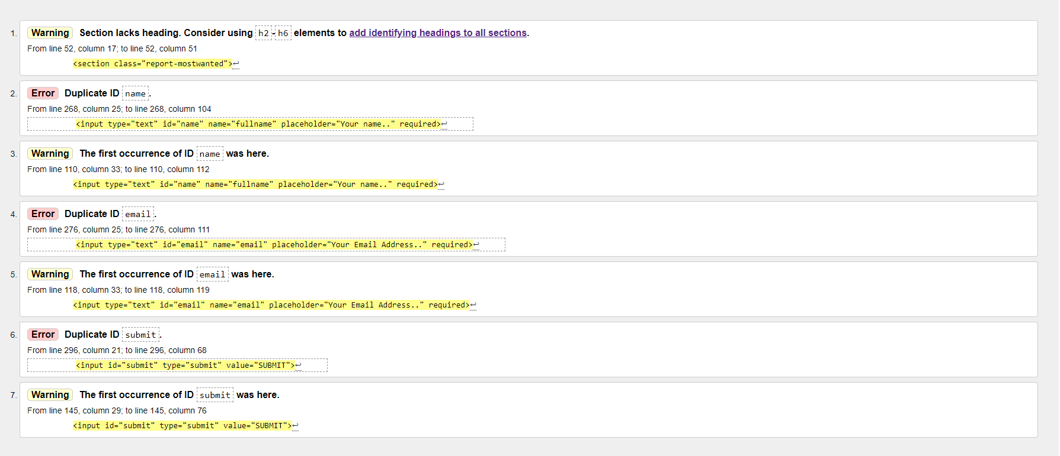

There were no errors found on ‘news.html’, however ‘reportajedi.html’ returns these problems. Similar to previous sections, the header has been moved within instead of outside of it. Because this page had multiple forms, it contained duplicate id’s. As they are designed to only be used once; they were changed to prevent these errors from occurring again. After re-validating the page, all were clear.

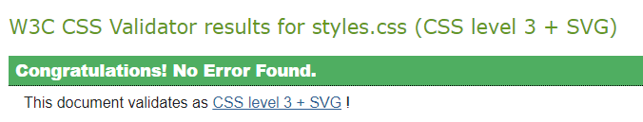

‘styles.css’ showed no errors when validated.

**Task 3. Peer review**

The website was shown to multiple people; one of a similar age and technical knowledge, one of a middle age and some technical knowledge, as well as an elderly person with no technical knowledge. Each were given the website without an explanation of what the website is or what it’s for and asked to experiment with the page. After 10 minutes these were the responses I received

Similar age:

“I understand what the website is showing, and it has an interesting concept. I enjoyed the navigation features and attention to detail given throughout the site. While I don’t know much about Star Wars, there wasn’t really a need for it as this site gives plenty of information. However, I did notice some images were slightly cropped on the ‘News’ page while loading it onto my tablet. But it is easy to use and contains a consistent and modern design. “

Middle age:

“This website is easy to use and looks great, perfect choice of colour to match the aesthetic. I love how it works on both my laptop and phone easily without losing any information. The small animations add to the experience of reading through the site and it was simple to navigate. The only problem I had with this site is understanding the ‘join us’ button. It wasn’t clear this wasn’t a website link and surprised me when it opened a box on top of the page I was on. I especially enjoyed the ‘Report a Jedi’ website page, it used photos well and had a good balance of those and text.

Elderly:

“I love it’s imitation of army recruitment websites. I struggled to get round at first, the buttons weren’t something I had seen before. But I quickly learnt how they worked and what to do. I’m not quite sure about the information as I don’t have a lot of prior knowledge with ‘Star Wars’. I enjoyed the use of imagery and colour choices used throughout.